**Linux Commands Assignment**

Question 1 : Creating and Renaming Files/Directories

1. First I have used the command mkdir which is used to create a [folder/directory].
2. Then I used the command cd to enter that specific directory.
3. After entering the folder which I have created (test_dir), I used the command touch to create a file in the directory.
4. At last, I used the mv command to rename my file.

Screenshot:

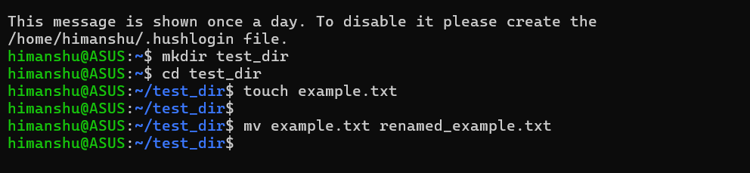

Question 2 : Viewing File Contents

1. First I have used mkdir command to create a directory named etc
2. Then I used command cd to enter that directory.
3. Used command touch to create a file called passwd inside the etc directory.
4. Then used command echo to write inside the file passwd which I have created.
5. After writing all the temporary lines, I have used the command head to showcase the first 5 lines and then tail to view the last 5 lines.

Screenshot:

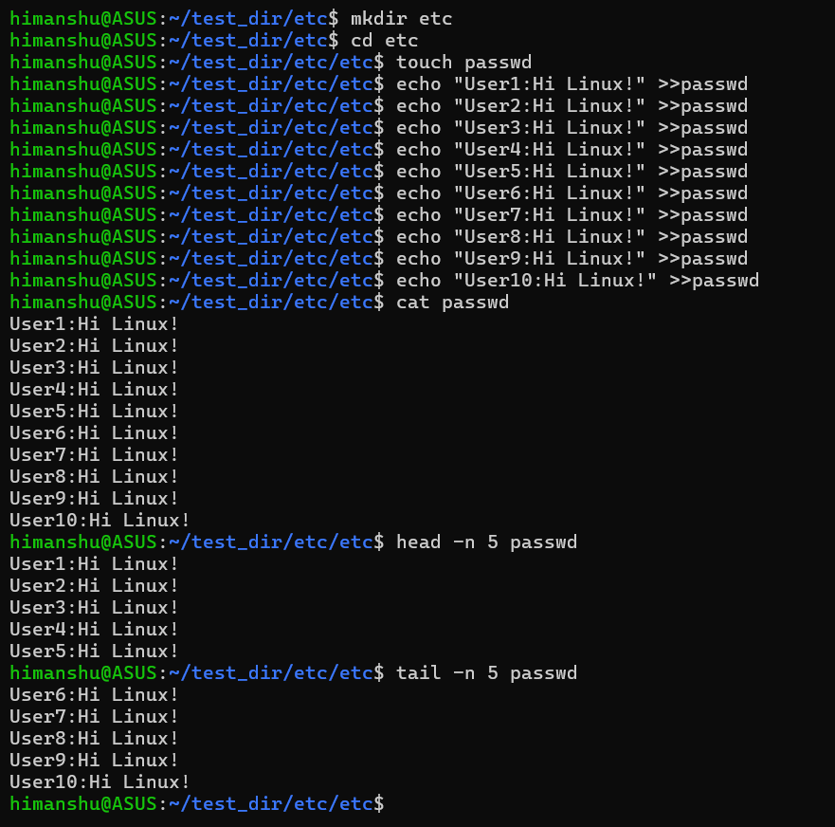

Question 3 : Searching for Patterns

1. In this I have used AI to create a random story for me then I used command echo to write that story in the file named passwd.
2. Then I have used grep command to find word “root”  
     
   Screenshot:  
     
   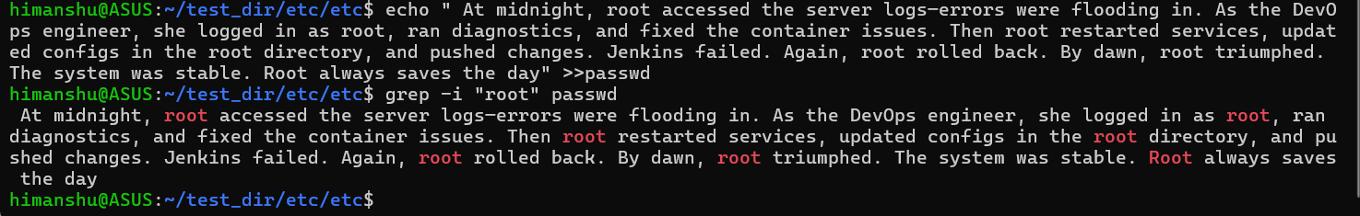

Question 4 : Zipping and Unzipping

1. First I have used command ls to locate files and when I see test_dir I have used command zip to zip the folder test_dir into test_dir.zip
2. Then I used command mkdir to create the new directory called unzipped_dir
3. Lastly use command unzip to unzipped the test_dir.zip into the new directory unzipped_dir

Screenshot:

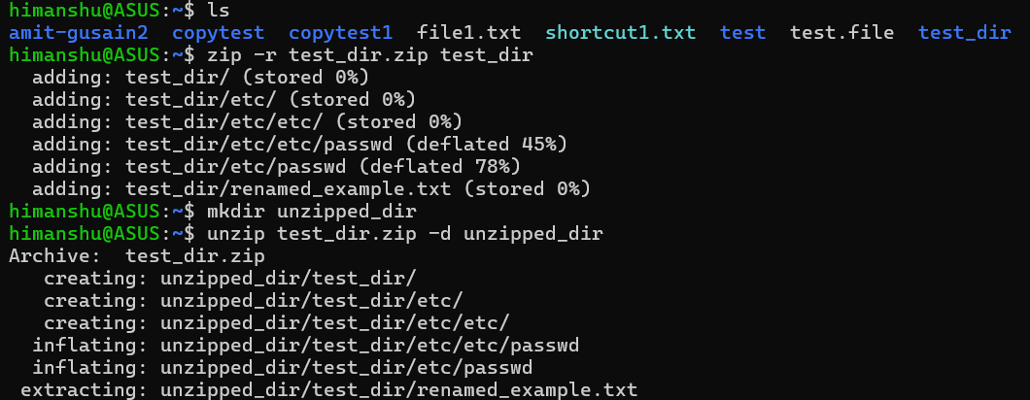

Question 5 : Downloading Files

1. I have use command wget to download the files as sample.txt
2. Then used command cat to view the files of sample.txt

Screenshot:

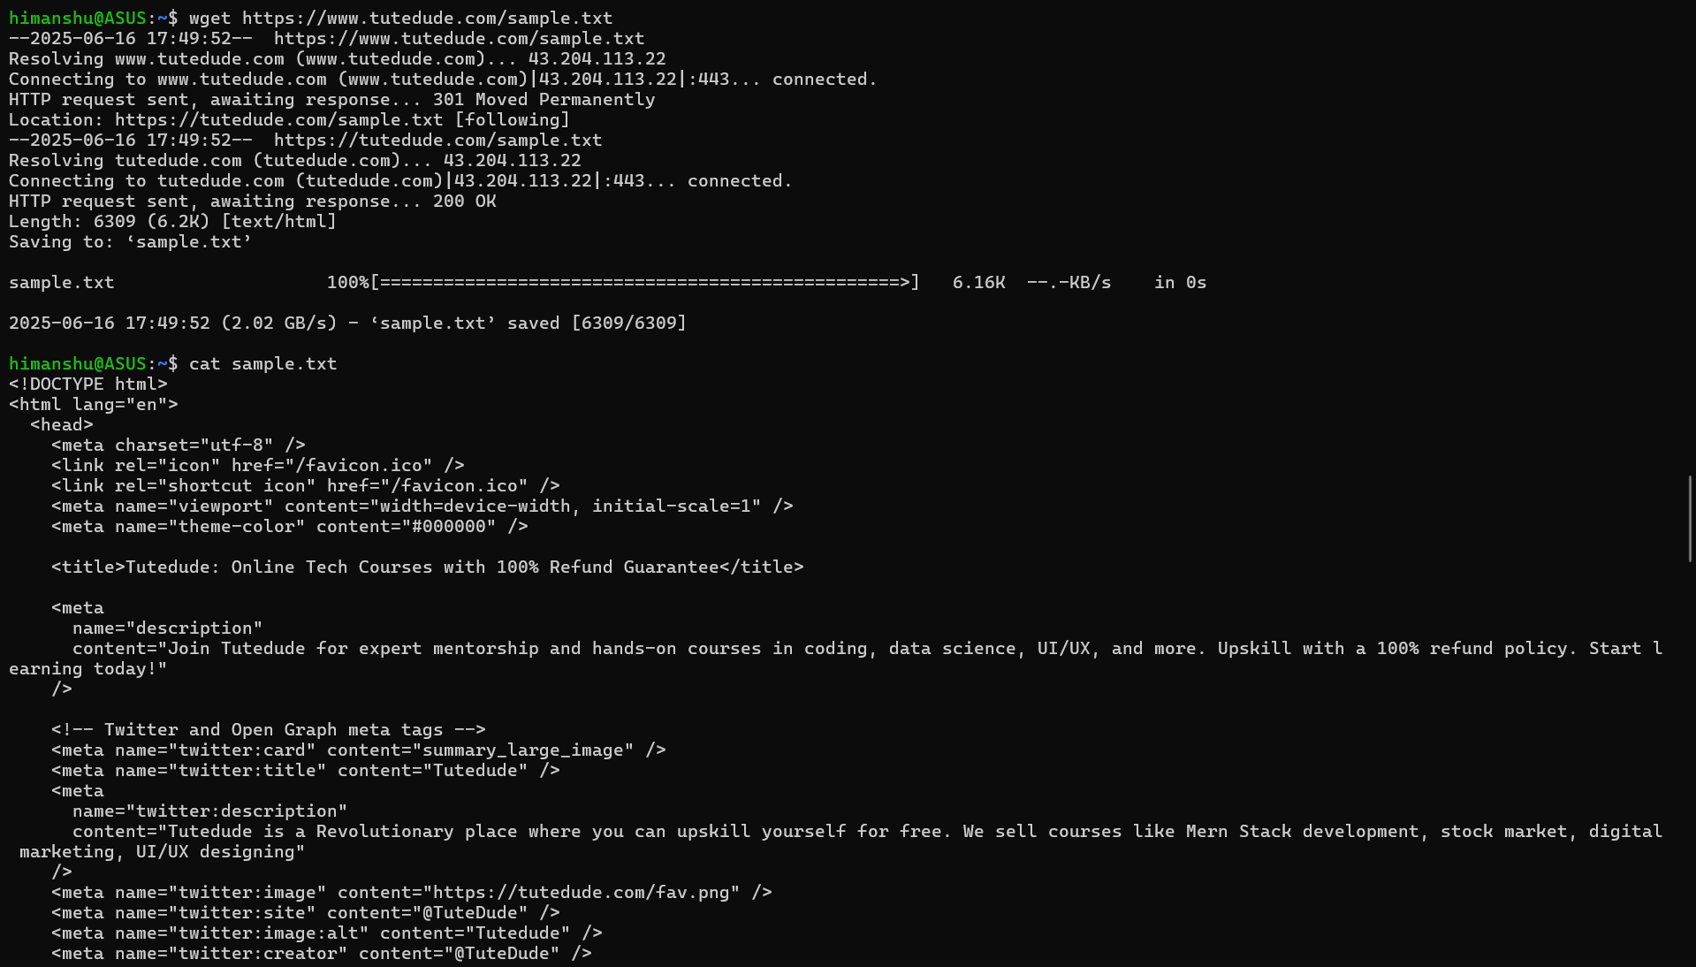

Question 6 : Changing Permissions

1. I have used command touch to create a file named secure.txt
2. Then used command chmod 444 secure.txt to give permission to read to everyone.
3. Then used command ls-al to check the permissions of each file.

Screenshot:

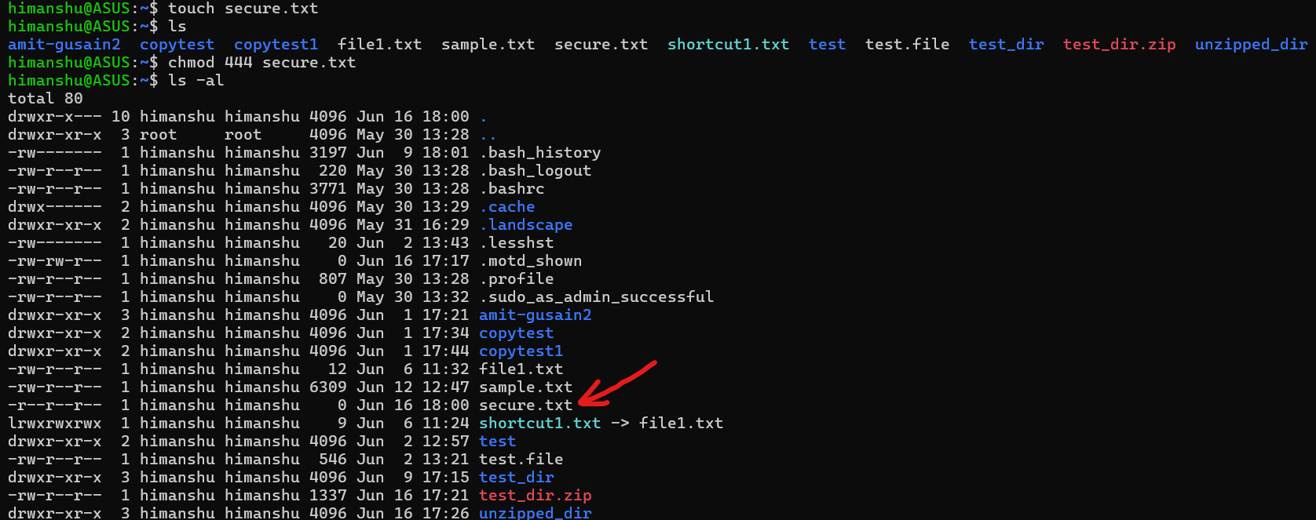

Question 7 : Working with Environment Variables

1. I have used command export as this command sets a new environment variable MY_VAR with the value "Hello, Linux!"

Screenshot:

